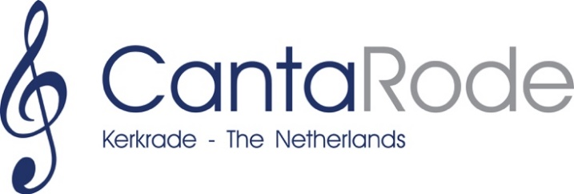

CANTARODE INTERNATIONAL CHORAL FESTIVAL KERKRADE

Thursday, May 29 – Sunday, June 1st, 2025

Artistic Director: Dion Ritten

REGISTRATION FORM 2025

Name of the choir :__________________________________________________
Place of residence/country :__________________________________________________
Number of members :__________________________________________________

Category chamber choir (12-32 singers):
Mixed choir : 0
Men’s choir : 0
Women’s choir : 0

Category large choir (33 singers or more):
Mixed choir : 0
Men’s choir : 0
Women’s choir : 0

Conductor
Name :__________________________________________________
Phone number :__________________________________________________
E-mail address :__________________________________________________

Contact information choir
Name Contact pers :__________________________________________________
Postal address :__________________________________________________
__________________________________________________
Landline phone :__________________________________________________
Mobile phone :__________________________________________________
Email address :__________________________________________________
Website choir :__________________________________________________
Checklist:

Choirs wishing to enter CantaRode International Choir Festival must send in this registration form accompanied by the following documents/items through the post to:

Stichting CantaRode
c/o Verdipassage 2
6461 DS Kerkrade
The Netherlands

or by e-mail to info@cantarode.nl:

- A completed registration form.
- A recent brief curriculum vitae of the choir in English and/or Dutch.
A recent brief curriculum vitae of the conductor in English and/or Dutch.
Curriculum vitae of choir and conductor combined should not exceed 250 words.
- Title, composer and lyricist, as well as a brief summary of each particular choral work in English or Dutch.
- A program proposal for the Cantarode Region Concerts on Friday night, with a duration of 30-40 minutes.
- Two recent digital pictures of the choir and a recent digital picture of its conductor in one of the following formats: .JPG or .TIFF, high-resolution, no less than 300 dpi.
- Five original scores of each composition to be performed during both rounds of the competition. These will be sent along as a pdf, together with the registration form. Upon arrival at the festival the original scores will be handed in at the secretarial office.
If dispatched through the post, the participating choir will take care of the costs.
- A recent recording in the form of a CD/DVD or MP3 of a live concert, no older than two years, containing at least three a cappella compositions.

Important notes:

- The registration form and the compulsory attachments must be received by the secretarial office not later than December 15, 2024.
- Registrations will only be accepted if all compulsory documents and scores have been entered completely and on time.
- The entrance fee of € 300, - per choir has to be transferred not later than
February 1, 2025 to the following bank account:
  - IBAN: NL36 RABO 0302 6344 60
  - BIC: RABONL2U
  - in the name of Stichting CantaRode
Any additional bank charges will be paid by the registered choir.
- Each choir is free to determine the order of the compositions to be performed. The final order, however, must be sent to the secretarial office (info@cantarode.nl) not later than April 1, 2025.
- By the end of January 2025, or sooner if possible, the registered choirs will be notified whether or not they have been admitted to the festival. This admission will, however, only be final after receiving the entrance fee.

Official registration of the board

The board hereby applies to enter the International Choral Festival CantaRode in Kerkrade (the Netherlands), to be held from May 29 – June 1, 2025.

The board has taken note of and agrees with the rules of the competition as laid down for CantaRode 2025 (www.cantarode.nl).

Signature:

City :

Date :

Chairman Secretary

(name and signature) (name and signature)

Compositions to be performed

Competition Round 1: (compulsory compositions; duration:
min. 17 – max. 20 minutes accurate singing time)
Performing more than one composition per style period is permitted.

Renaissance/baroque
Title : ________________________________________________
Composer/lyricist : ________________________________________________
Duration : ____ minutes
A Cappella : compulsory

__________________________________________________________________________
Romanticism
Title : ________________________________________________
Composer/lyricist : ________________________________________________
Duration : ____ minutes
A Cappella : compulsory

__________________________________________________________________________

Composition from the 20th of 21st century
Title : ________________________________________________
Composer/lyricist : ________________________________________________
Duration : ____ minutes
A Cappella : compulsory

__________________________________________________________________________

Post 1985 composition from the country of origin
Title : ________________________________________________
Composer/lyricist : ________________________________________________
Duration : ____ minutes
A Cappella : compulsory

Competition Round 2: (Free program, duration: min. 17 – max. 20 minutes accurate singing time

Title : _________________________________________________
Composer/lyricist : _________________________________________________
Duration : ____ minutes
A Cappella : 0
Piano accompaniment : 0
Other accompaniment : 0

__________________________________________________________________________

Title : _________________________________________________
Composer/lyricist : _________________________________________________
Duration : ____ minutes
A Cappella : 0
Piano accompaniment : 0
Other accompaniment : 0

__________________________________________________________________________

Title : _________________________________________________
Composer/lyricist : _________________________________________________
Duration : ____ minutes
A Cappella : 0
Piano accompaniment : 0
Other accompaniment : 0

__________________________________________________________________________

Title : _________________________________________________
Composer/lyricist : _________________________________________________
Duration : ____ minutes
A Cappella : 0
Piano accompaniment : 0
Other accompaniment : 0

__________________________________________________________________________

Title : _________________________________________________
Composer/lyricist : _________________________________________________
Duration : ____ minutes
A Cappella : 0
Piano accompaniment : 0
Other accompaniment : 0

